[Manuscript Title: Bold, Center, 14pt, Maximum 15 Words]
First Author^{*1 [0000-1111-2222-3333]} and Second Author^{2[1111-2222-3333-4444]}
¹ Princeton University, Princeton NJ 08544, USA
² Springer Heidelberg, Tiergartenstr. 17, 69121 Heidelberg, Germany
Corresponding Email: user@unhas.ac.id
Abstract
Provide a concise and self-contained abstract in one paragraph of 150–250 words. For empirical studies, the abstract should briefly describe the research problem, objective, research design or method, data or participants, principal findings, and main conclusion or implications. For review, conceptual, or case-based papers, state the purpose, approach, principal arguments or findings, and contribution of the manuscript. Do not include citations, tables, figures, undefined abbreviations, or claims that are not supported by the main text. The relevance of the manuscript to the theme and scope of ICAME XI should be clearly demonstrated without repeating the conference theme verbatim. Ensure it aligns with the summit theme: Navigating The Intelligent Economy: Innovation and Governance
Keywords: Keyword 1; Keyword 2; Keyword 3 (Provide 3 to 5 pertinent keywords specific to the article).
1. INTRODUCTION
The Introduction should establish the background and context of the study, explain the research problem, identify the relevant research gap, and state the objective or research questions. It should also explain the significance and contribution of the manuscript to accounting, management, economics, finance, innovation, governance, sustainability, or other areas within the scope of ICAME XI.
Authors should not make unsupported claims regarding novelty or contribution. The relevance to digital transformation, sustainable development, the intelligent economy, or the ASEAN context should be discussed only when it is directly relevant to the study.

The Introductin and Literature Review sections may be combined where this improves coherence.
2. LITERATURE REVIEW
The Literature Review should critically engage with current and relevant research while also acknowledging important foundational works. It should synthesize previous findings, identify areas of agreement, disagreement, and uncertainty, and explain how the present manuscript addresses an identified gap.
Where appropriate, the literature review should establish the theoretical or conceptual foundation of the study and support the development of hypotheses, propositions, or a conceptual framework. Hypotheses are not mandatory for qualitative, conceptual, review, exploratory, or case-based studies.
Authors should avoid presenting the literature review as a sequence of disconnected summaries. Sources should instead be compared, evaluated, and synthesized to build a coherent argument.
3. METHODOLOGY
Describe the research design and explain its suitability for addressing the research objective or questions. Provide relevant information on the research setting, data sources, participants or cases, sampling or selection procedures, instruments, data collection, and analytical techniques. Quantitative studies should report statistical procedures and software, while qualitative, review, conceptual, and case-based studies should describe their respective data collection, analysis, selection, or synthesis processes. Explain relevant measures of validity, reliability, robustness, or trustworthiness.
Studies involving human participants, personal data, or sensitive information must report applicable ethical procedures, including ethical approval and informed consent.
4. RESULTS AND DISCUSSION
Present the findings clearly and in a logical sequence that corresponds with the research objectives, questions, hypotheses, or propositions. Report the findings accurately and avoid overstating their significance.
The Discussion should interpret the findings rather than merely repeat them. Relate the results to the relevant theories, previous studies, and the wider context of accounting, management, economics, finance, innovation, governance, or sustainability. Explain agreements, differences, unexpected findings, and their possible implications.
The Results and Discussion may be presented as one combined section or as two separate sections, depending on the research design and disciplinary convention.
For review, conceptual, and case-based manuscripts, this section may be titled “Analysis and Discussion,” “Findings and Discussion,” or another suitable heading.
Table 1. Descriptive statistics
Variables | Min | Max | Std. Dev.
Performance | 1.10 | 4.52 | 0.89
Innovation | 1.00 | 4.83 | 0.91
Motivation | 3.22 | 4.98 | 0.72
Wage | 4.21 | 4.30 | 0.81
FirmSize | 0.01 | 4.00 | 0.99
Source: xxx (2025)
Notes: xxx

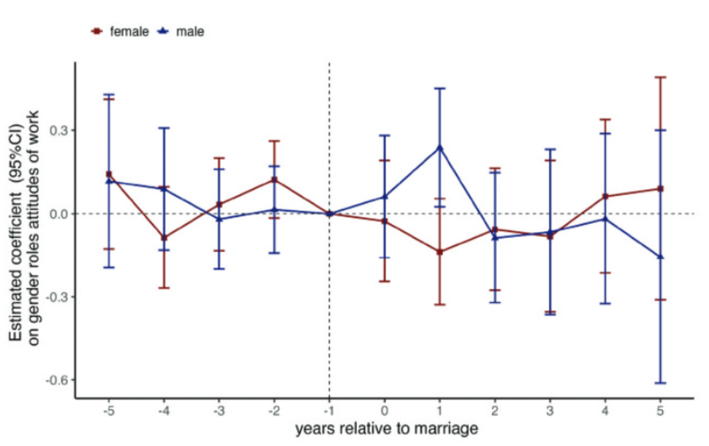
Figure 1. Work during recession
5. CONCLUSION
Summarize the answers to your research questions and provide managerial implications.
References
Use APA 7th edition consistently. Ensure every in-text citation appears in the reference list.
Example:
Author, A. A. (Year). Title of article. Title of Journal, volume(issue), pages. DOI/URL.

